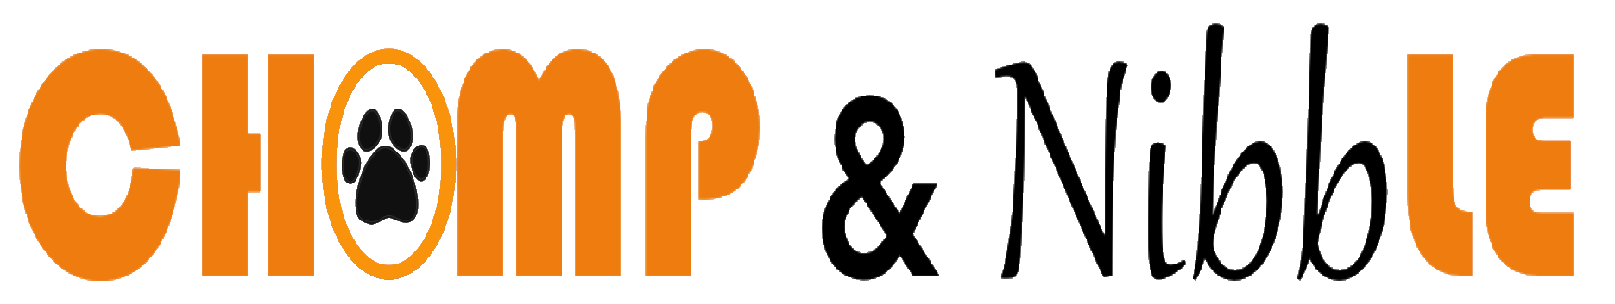

Please complete and return before your first order.

ABOUT YOU
Name: | Date:
Delivery address:
City: | Zip code:
Email: | Phone #:
How did you hear about Chomp & Nibble?
If referred, please put person’s name:

ABOUT YOUR DOG, #1
Pet’s name: |  | Breed:
Age: | Weight: |  | Allergies: yes no
Please describe allergies:
Is your pet on a special diet: yes no
Please describe your pet’s special diet:
How often do you feed your dog?
What brand of food do you currently serve? |  |  |  | wet kibble

ABOUT YOUR DOG, #2
Pet’s name: |  | Breed:
Age: | Weight: | Allergies: yes no
Please describe allergies:
Is your pet on a special diet: yes no
Please describe your pet’s special diet:
How often do you feed your dog?
What brand of food do you currently serve? |  |  | wet kibble

ACCOUNT SET-UP

- Have you read our Frequently Asked Questions page?

If you have any questions about our food or service, contact Chomp & Nibble at:
paula@chompandnibble.com or (650) 704-7148.

- Have you ordered your first delivery?
If not, please visit our order page, and place your first order.

- Chomp & Nibble is delivered weekly on Mondays and Tuesdays, between 5:00-6:00pm. What day would you like your meals delivered?

Special Delivery Instructions:

---------------------------------------------------------------------------------------------------------------

Electronic Signature (type name above) | Date

